|  |  |  |  |  |
| --- | --- | --- | --- | --- |
| SN | Item | Photo | Supplier | Remark |
| 1 | SX 1301 Based Lora Concantrator/Gateway |  |  |  |
| 2 | SX 1272/6 Based LORA modules(100 mW) |  |  |  |
| 3 | SX 1276 Based LORA modules(500 mW) |  |  |  |
| 4 | Breakout Board for SX 1272/6 Based LORA modules(100 mW) |  |  |  |
| 5 | Breakout Board for SX 1276 Based LORA modules(500 mW) |  |  |  |
| 6 | Raspberry PI | Raspberry Pi 3 Model B SBC |  |  |
| 7 | Arduino or other controller for Node | Arduino Uno R3 with USB Cable by Rees52.com |  |  |
| 8 | Antenna(Indoor) |  |  |  |
| 9 | Antenna(External) | Base station antenna |  |  |
| 10 | Ethernet Cable -25 Meter |  |  |  |
| 11 | IP 66 /67 BOX for Gateway | Image result for ip 66 box |  |  |
| 12 | WIFI USB For Raspberry Pi |  |  |  |
| 13 | POE INJECTOR |  |  |  |
| 14 | POE SPLITTER | 6002D |  |  |
| 15 | LORA Gateway (Outdoor) | http://www.risinghf.com/wp-content/uploads/2016/06/RHF2S008-logo-480x480.png |  |  |
|  |  |  |  |  |

# Node to Node Communication

# In node to node communucation we would use one Lora node as transmissting and other node as receiving node. In our POC we have used SX1276 based node of 500 mW.

## Typical Pin Mapping from Arduion Uno to Lora board

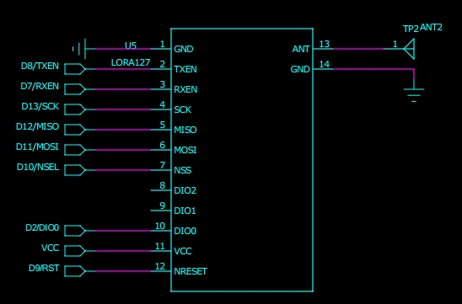

**Pin Mapping**

|  |  |
| --- | --- |
| **LORA BOARD** | **ARDUINO** |
| MOSI | DIO11 |
| MISO | DIO12 |
| CLOCK | DIO13 |
| NRST(RESET) | D9 |
| NSS(SELECT) | D10 |
| VCC | VCC |
| GND | GND |

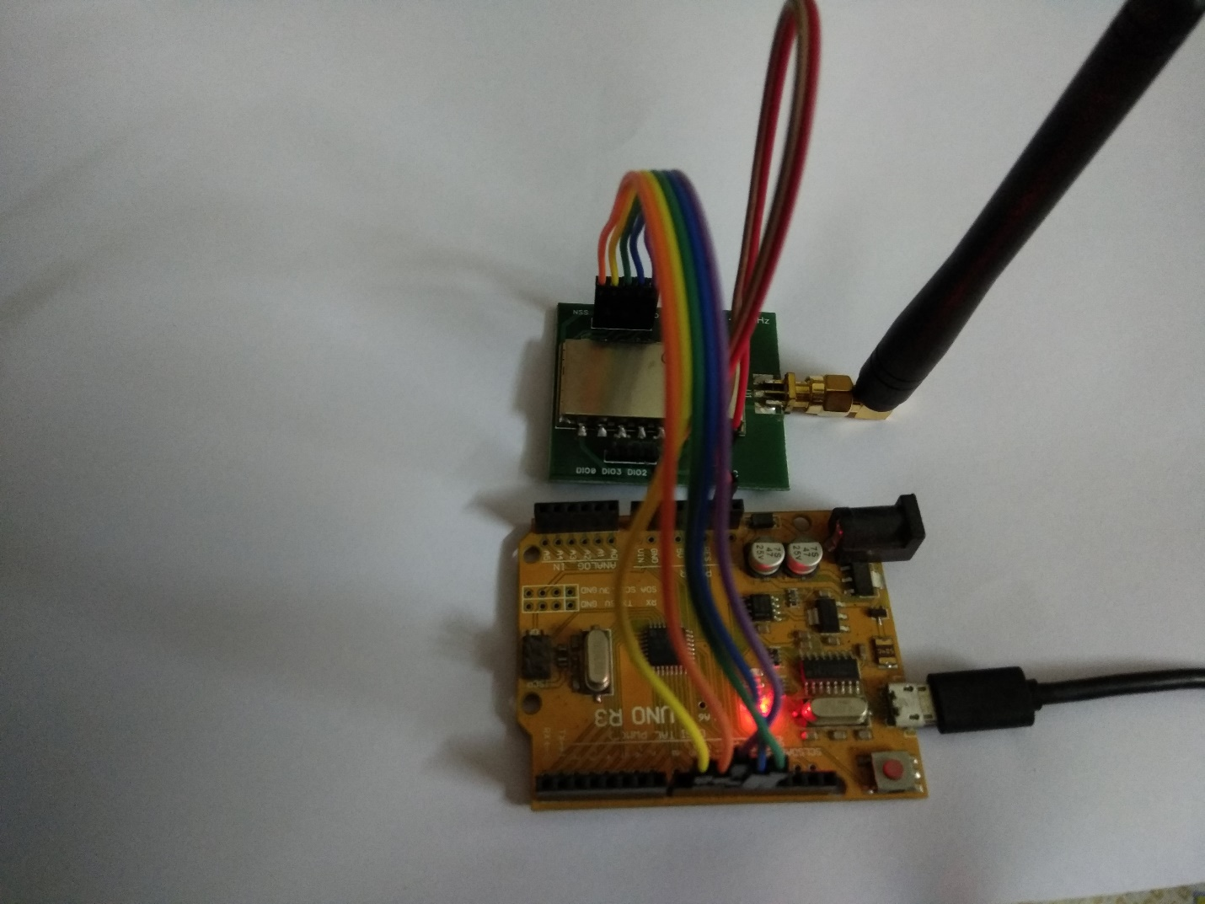

**Arduino Lora Node**

**Setup**

|  |  |
| --- | --- |
| **Parameter** | **Value** |
| Bandwidth(BW) | 125 Khz |
| Spread Factor(SF) | 7 |
| coding rate | 4/5 |
| Power | 27dBm(500 mW) |
| Payload size | 28 Byte |
|  |  |
|  |  |

The source code base is uploaded to

https://github.com/tikiarya/LORA-NICERF/

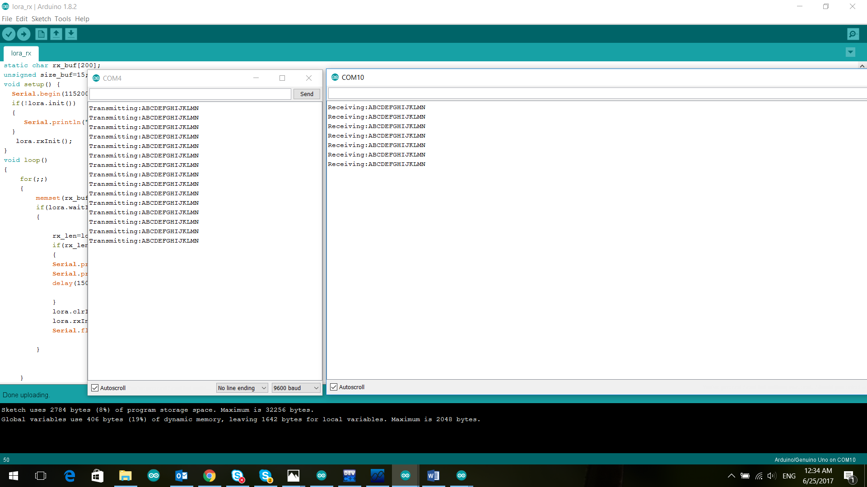

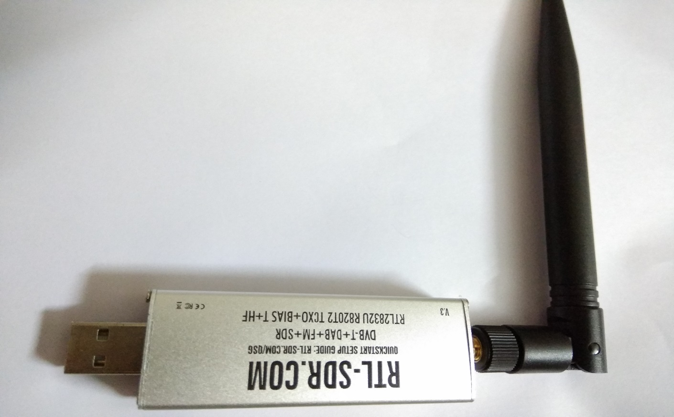

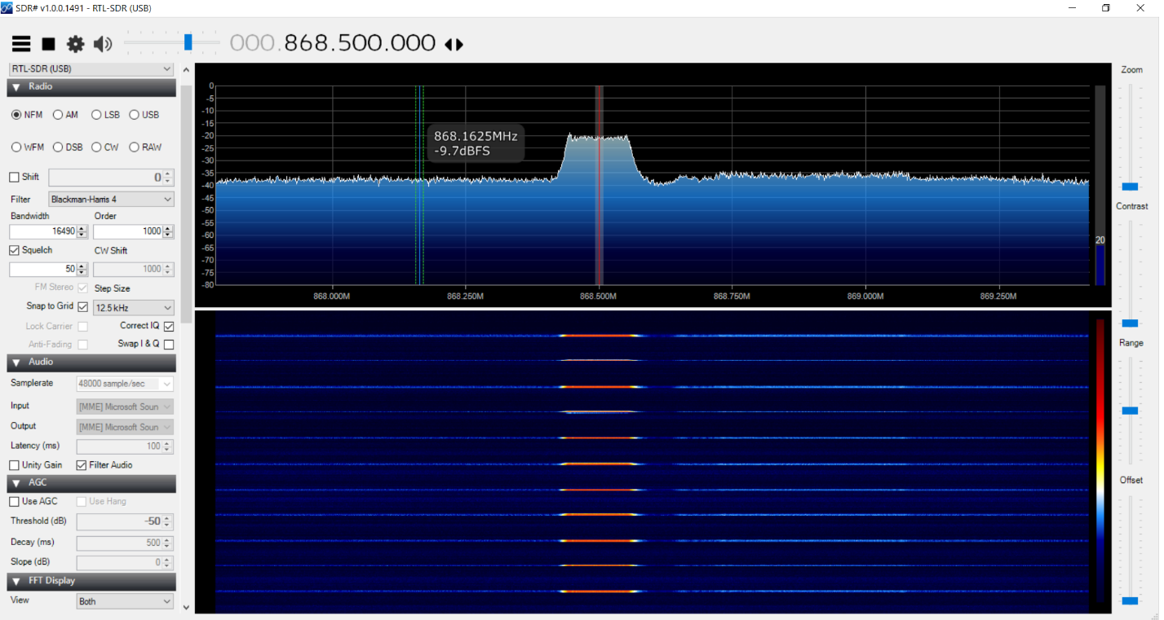Spectrum test

**How to connect SX1276 to The Things Network through gateway RHF0M301**

**Step1: Setup the Raspberry Pi**

* Burn the image file onto the SD card.
* Install the latest version of Raspbian Jessie Pixel.
* If you’re using Raspberry Pi3, enable SSH by creating an empty file in boot directory.

**Step2: SSH into PI using PuTTY**

* Open Putty terminal

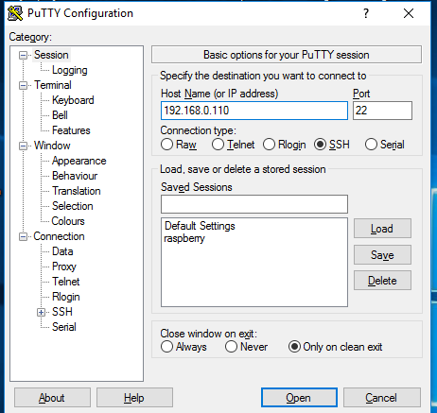

* Input the IP address of Pi (use IP scanner tool to find the IP address of the Pi assigned by the router).
* 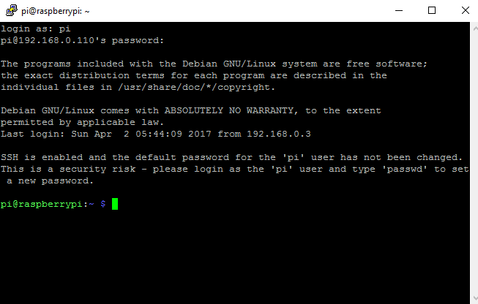Login as: pi Password: raspberry.

**Step 3:Enabling SPI: Without Enabling SPI the gateway cannot be accessed by the Pi**

* Use sudo raspi-config command and enable SPI.
* 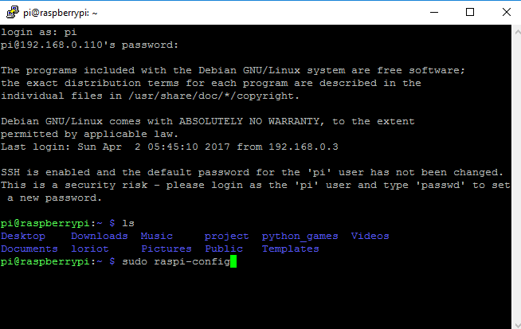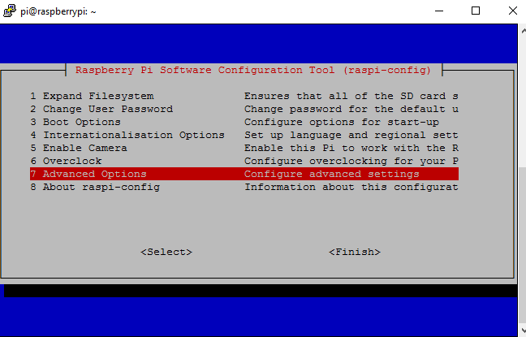Use the arrow keys to navigate.

**Step 4: Downloading packet forwarder and gateway related files from GitHUb repository.** (Make sure the Pi is connected to the internet)

* $ sudo mkdir ~/gateway
* $ cd ~/gateway
* $ git clone<https://github.com/Lora-net/lora_gateway.git>
* $ git clone<https://github.com/Lora-net/packet_forwarder.git>
* $ cd ~/gateway/lora_gateway
* sudo make all
* $ cd ~/gateway/packet_forwarder/lora_pkt_fwd
* 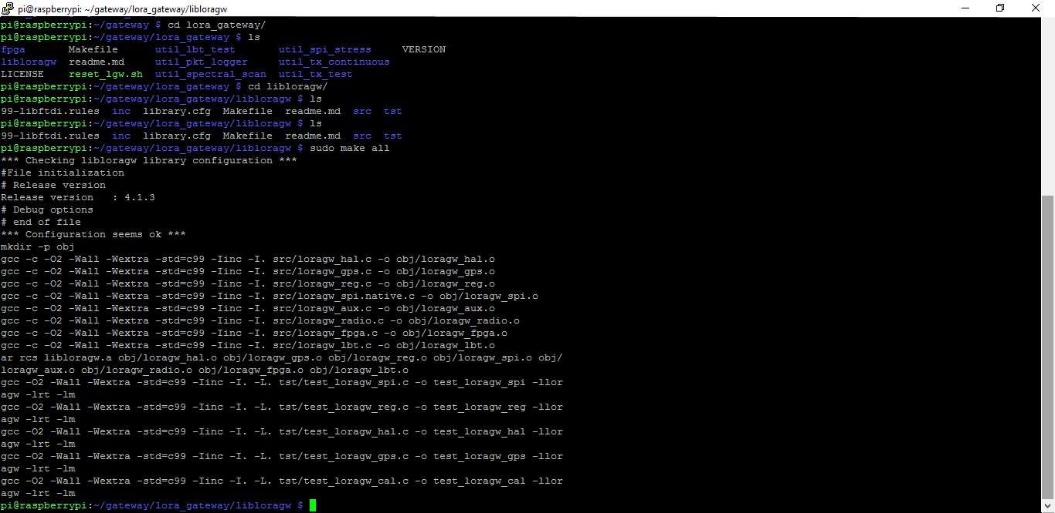sudo make all

**Step : Register the Gateway in TTN console**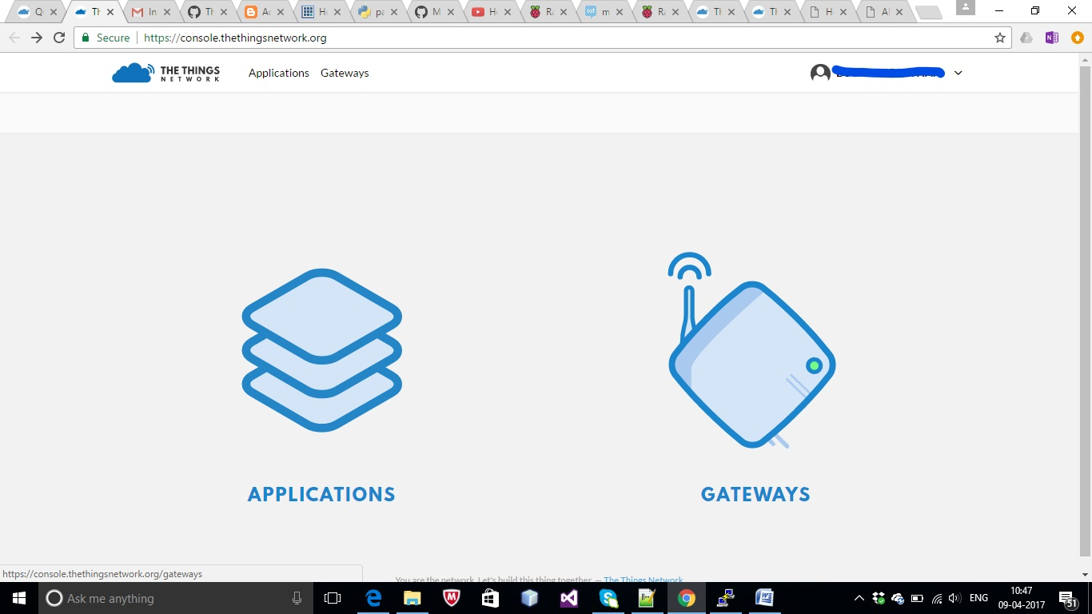

Click on GATEWAYS > Register Gateways and enter all fields.

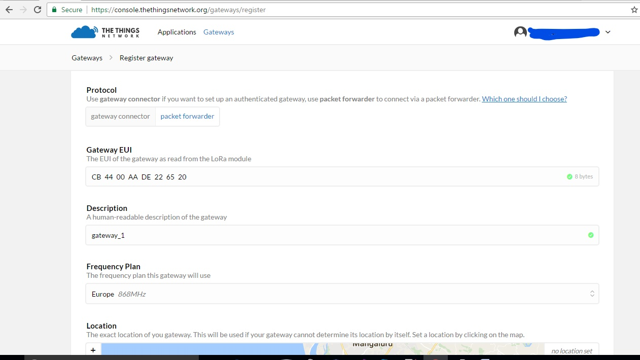

1). Set Protocol to Packet Forwarder.

2).Enter 8 bytes hex number Gateway EUI (the first byte should not start with ‘A’).

3). Set Frequency Plan as 868Mhz.

4).After entering all fields click on “Register Gateway” .

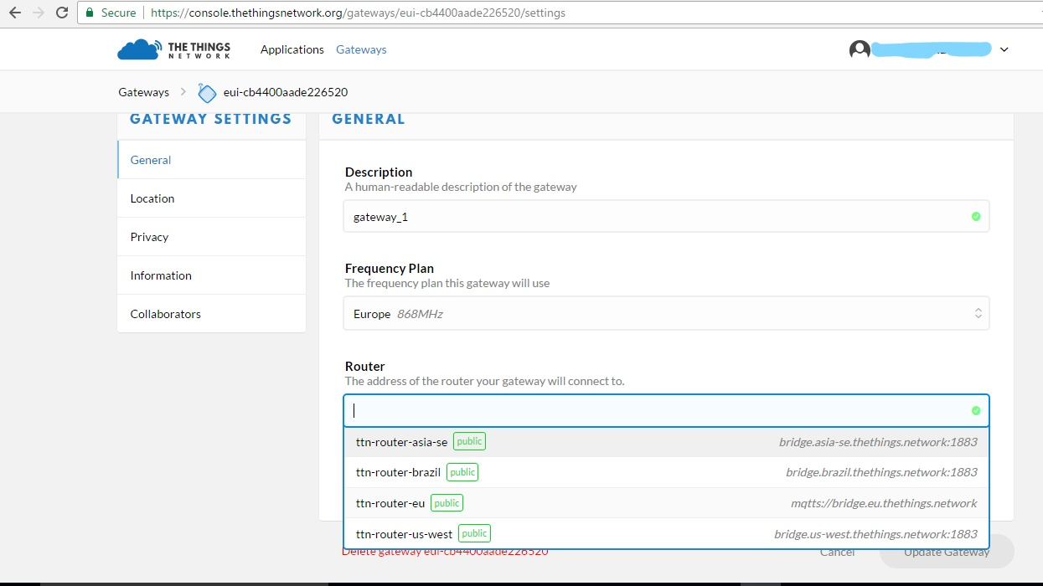

5).Click on the gateway (eui-cb4400aade226520) >Settings

6).Select the appropriate Address of the Router your Gateway will connect to and note down the link (i.e. mqtts://bridge.eu.thethings.network) and also the port number (usually 1883).

**Step 5: Connecting to the server**

·**Reset the GPIO7:** cd gateway/lora_gateway $ sudo ./reset.lgw.sh start .

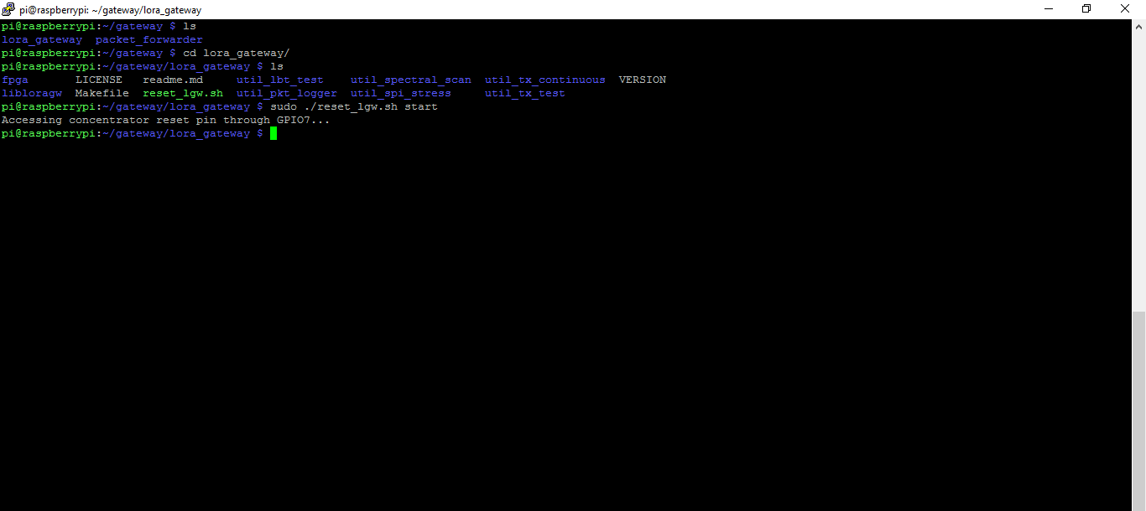

Reseting the GPIO7 is the important step which must be executed without fail before running the packet forwarder (i.e with every restart of the packet forwarder reseting of GPIO7 should be executed).

Configure the global_conf.json by changing the gateway ID, Server address, serv_port_up/down as given by the cloud service provider.

From reset.lgw.sh

# The reset pin of SX1301 is wired with RPi GPIO7

# If used on another platform, the GPIO number can be given as parameter.

if [ -z "$2" ]; then

IOT_SK_SX1301_RESET_PIN=7

else

IOT_SK_SX1301_RESET_PIN=$2

Fi

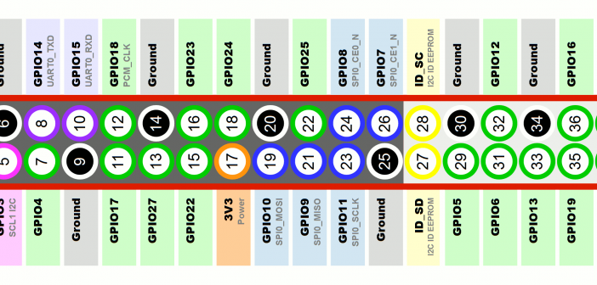

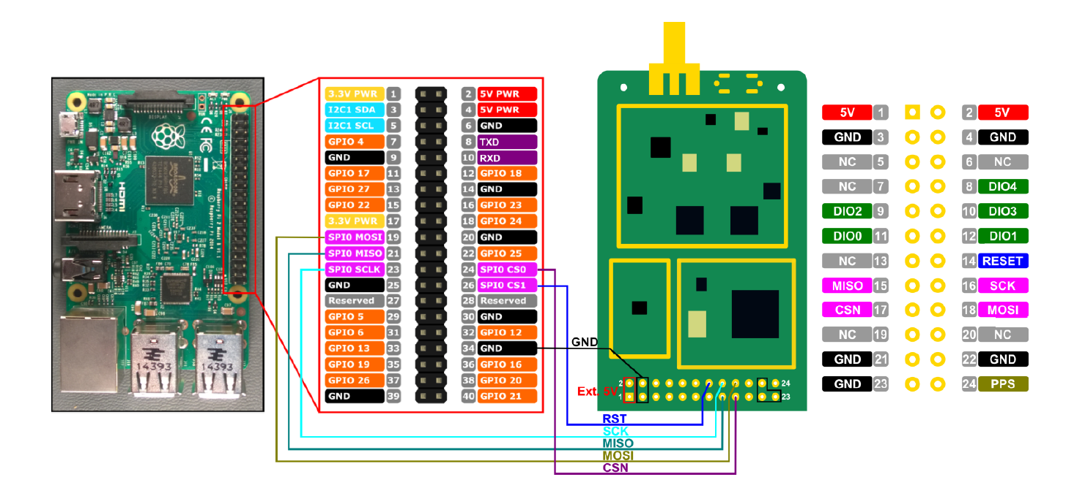

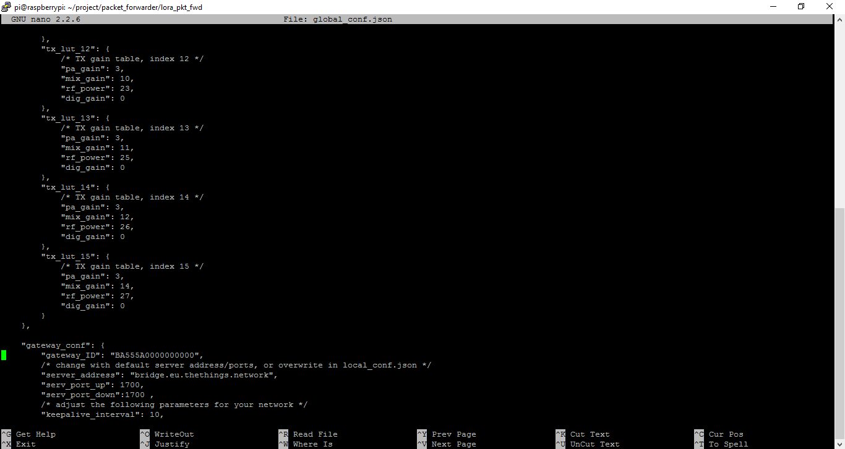

1. Open global_conf.json edit the **gateway_ID** by Gateway EUI(i.e cb4400aade226520) ,
2. Change server_address to router address (i.e. mqtts://bridge.eu.thethings.network).
3. Set the appropriate Port number (i.e 1883).
4. The clock source should appropriate ,1 for RisingHF concentrator

|  |  |
| --- | --- |
| "SX1301_conf": { |  |
|  |  | "lorawan_public": true, |
|  |  | "clksrc": 0, /* radio_1 provides clock to concentrator */ |
|  |  | "antenna_gain": 0, /* antenna gain, in dBi */ |

1. 4). Type Ctrl+x , then type ‘y’ and press Enter.

·**Run packet forwarder:**

* cd packet_forwarder/lora_pkt_fwd
* 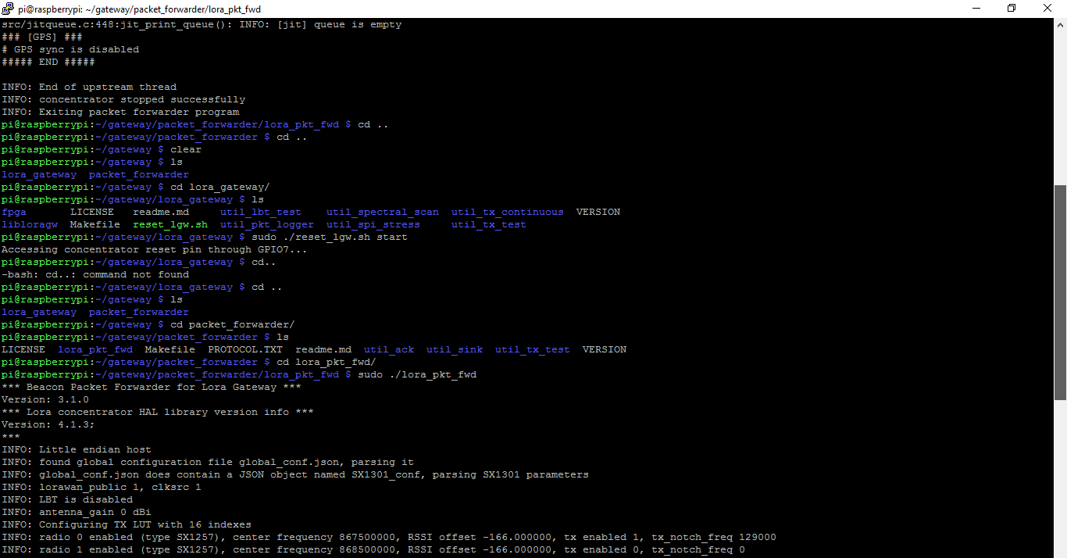$ sudo ./lora_pkt_fwd
* **Step 6: Connecting to TTN**
* Login to The Things Network and register the gateway to which the end-device is connected .
* The data transmitted by the end-device can be viewed in the application window .
* To view the data on console page the end-devices should be registered.
* Click on Applications > Add application and enter the below fields .

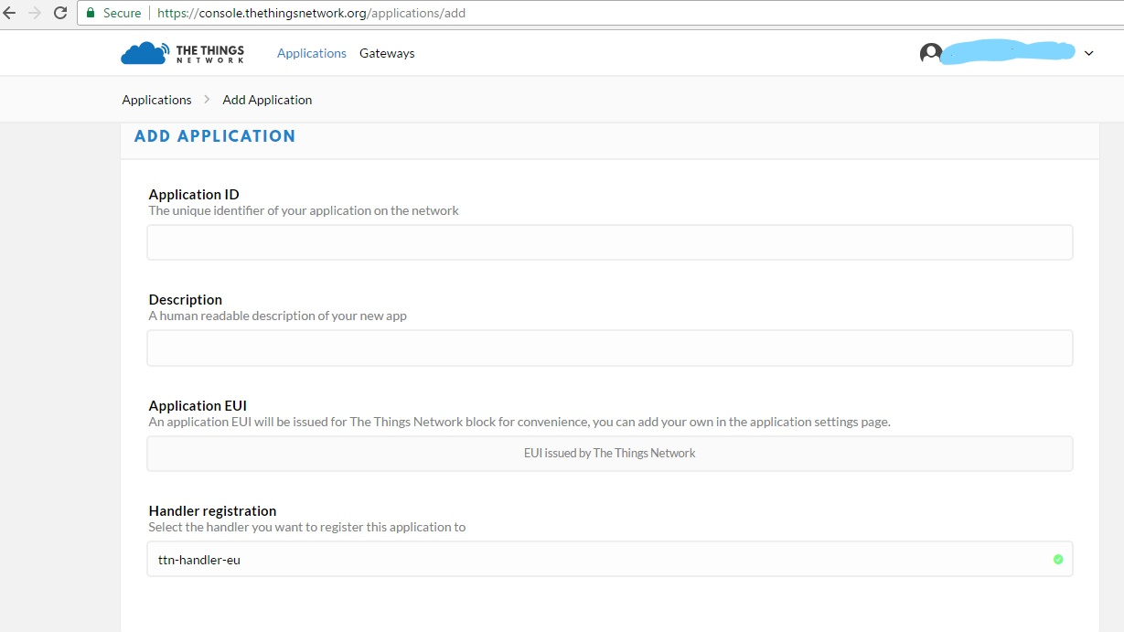

* After creating an application now register end-devices under each application.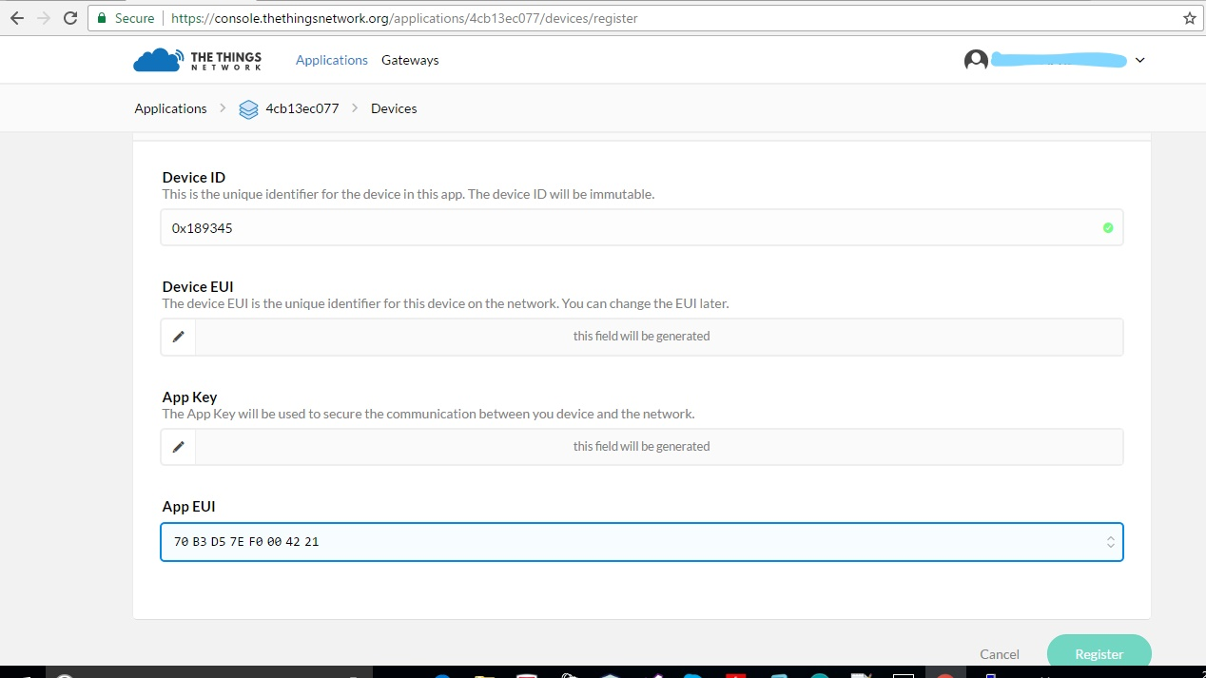
* Enter the 3 byte hex **Device ID** , then click on register.
* Set the **Activation method** to **ABP** .
* After successfully registering the end-devices , open the Arduino code and set the APPSKEY, NWKSKEY as generated in the page . Also set appropriate DEVADDR. Compile and run the code once done.

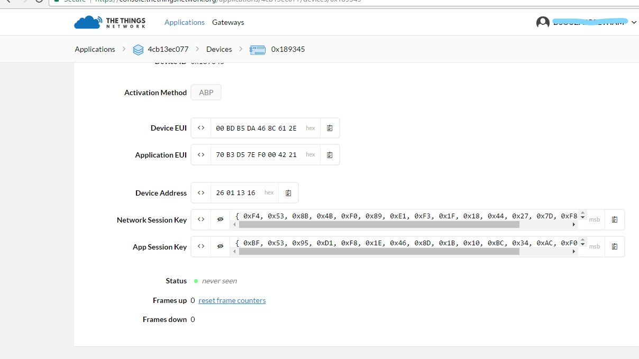

* Replace NWKSKEY, APPSKEY, DEVADDR in the ABP (example code of Arduino Lmic by  matthijs kooijman) Arduino code as generated in the TTN page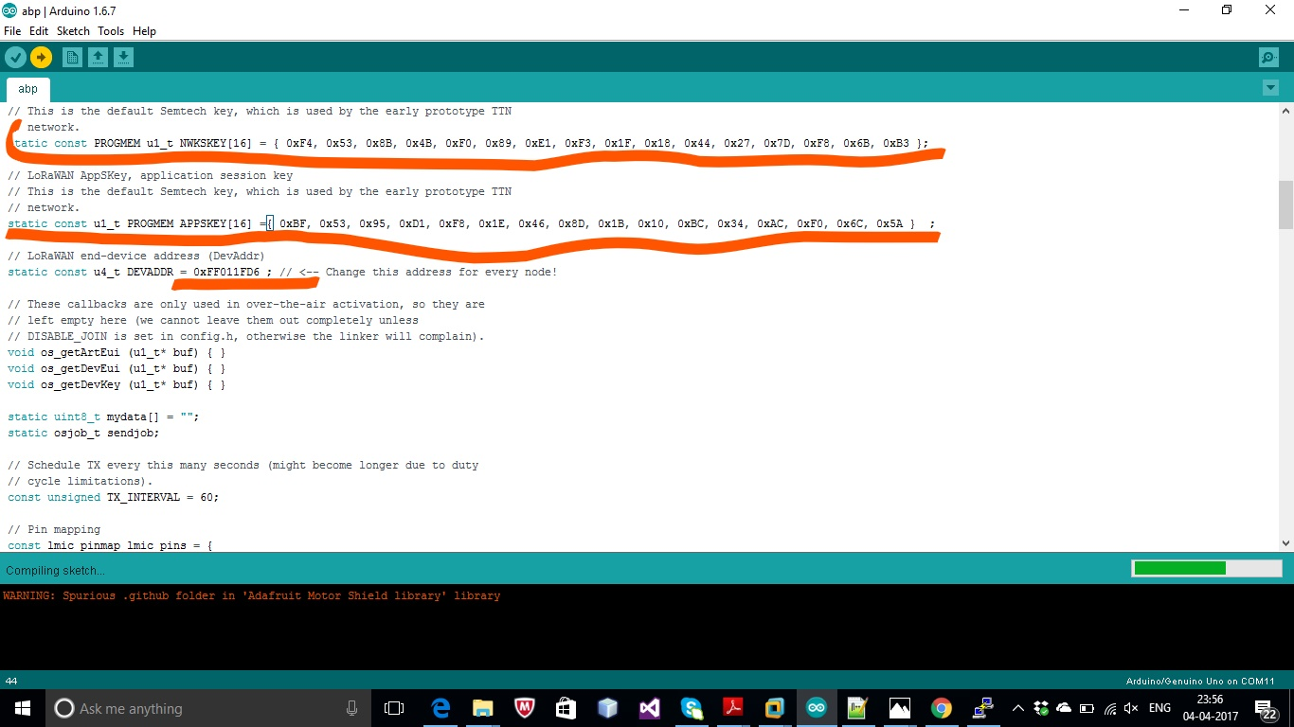

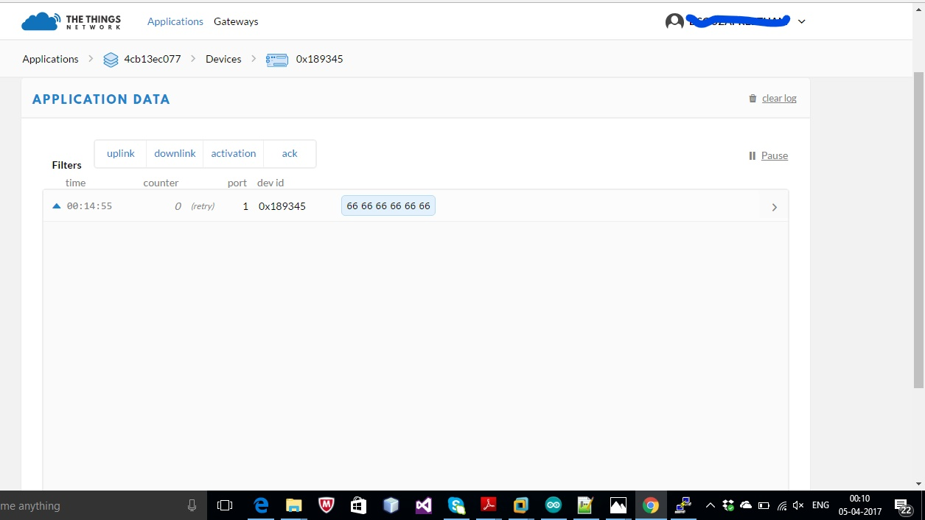

* Click on **Data** to view the incoming data from the end-devices .